
HYDRAMAX
HM1500RECSI

Hydraulically driven

AC GENERATOR
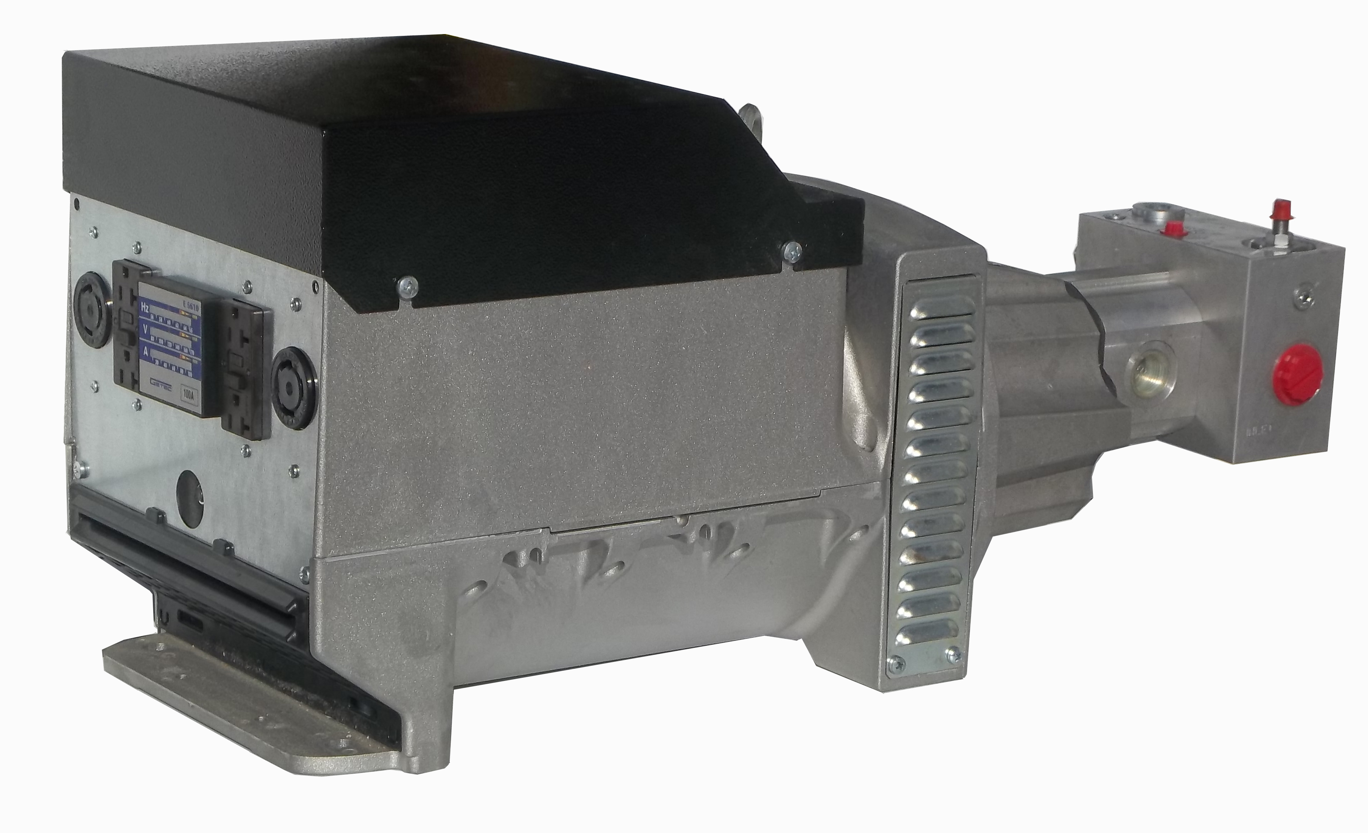

Voltage
120 V or
120/240 V

AC POWER
15000 Watt

FREQUENCY

60 HZ
50 HZ Models
available

Overall Efficiency 86 %
Operating Speed 3600 RPM
Minimum Flow 24 GPM
Ideal Flow 26 GPM
Maximum Flow 40 GPM
Free Air Flow 14 cfm
Recommended Filteration 10 m
Max.Oil Temperature 180 F
Min.Tank Size 30 Gal.
Features and Specifications
- Completely Brushless, Maintenance free.
- Pure Sinewave Output.
- Environmentally safe , no Pollution
- Can mount in any Position.
- Hydr.Motor includes Pressure compensating Flow Control. ( Build in )
- Will operate on Open and Closed Systems
- All this in a Package of 13” high , 11” wide and 29” long and weights only 142 Lbs
- The Hydraulic Requirement is 24 GPM @ 2200 PSI ( other Flow requirements are available )

(845)-292-0800
http://www.getec.com
email SALES@GETEC.COM

624 Harris Road
Ferndale New York 12734

