

HYDROMAX CC- 1200

Hydraulically driven
AC GENERATOR
Generator

Voltage
120 V or
120/240 V

AC POWER

12 000 WATT Cont.
14 000 Watt interm.

FREQUENCY
60 HZ

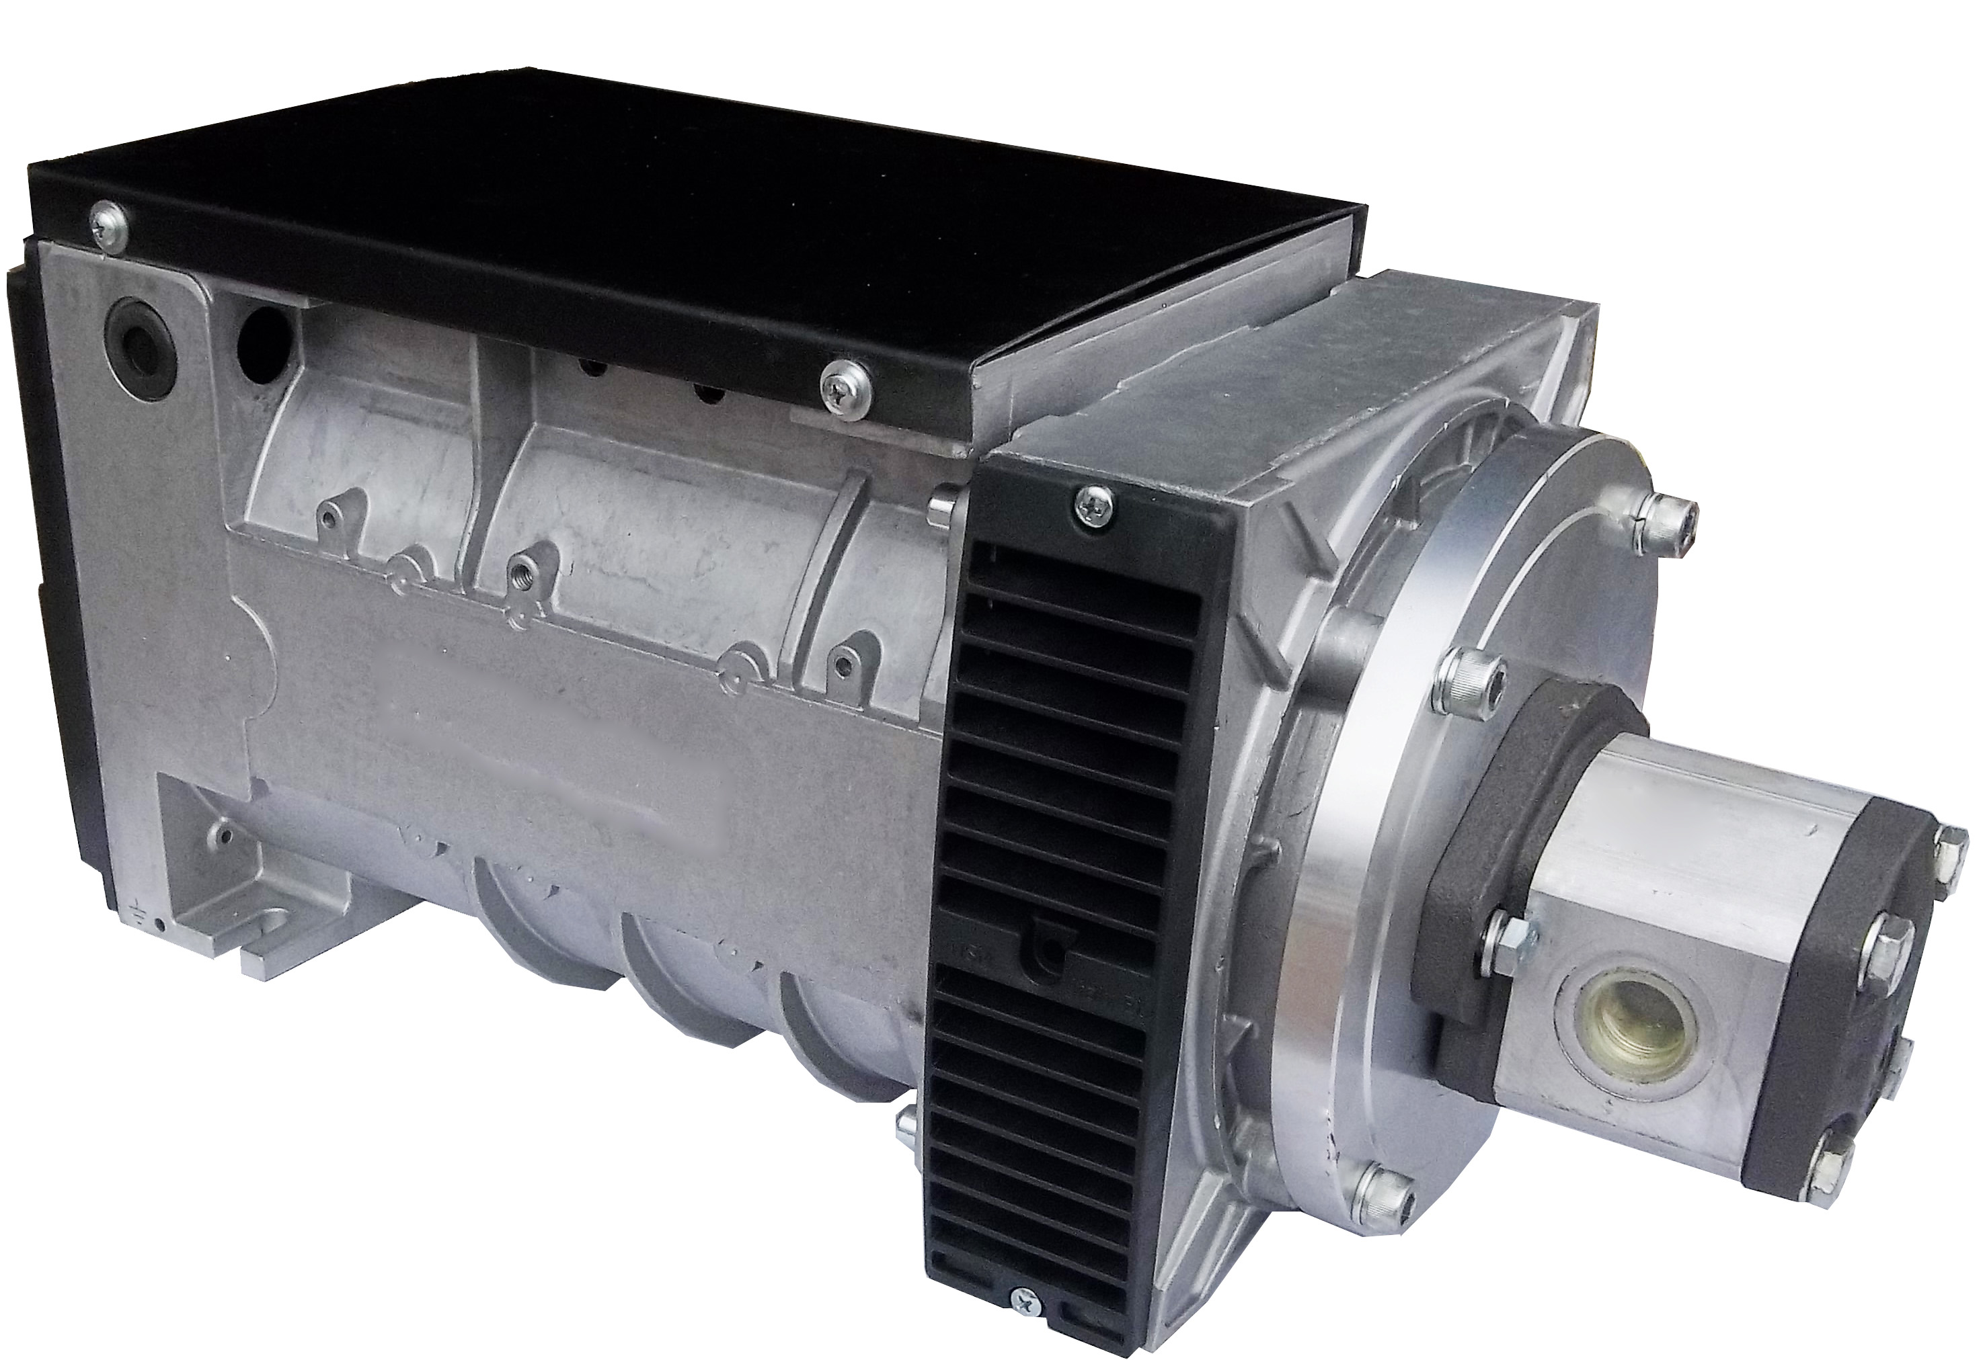
This innovating new Hydraulic
Drive by GETEC saves Space and Weight.
The length of this Generator has been reduced by 5 ½ inch.
This innovative Drive Design extends the life of the Hydraulic Drive by over 50 %.
The Weight of the Rotor is carried by the Generator Bearing and not by the Hydr. Motor Shaft like all other Designs.

Hydraulic Requirements

15 GPM @ 2450 PSI
18 GPM @ 2250 PSI

Mechanical

Speed 3600 RPM
Size 9.5 in H,9.5 in W,22 in L
Weight 112 LBS
(845)-292-0800
http://www.getec.com

624 Harris Road
Ferndale New York 12734
Electrical

Sinewave less than 4 % Distortion
Motor Starting 400 %
Voltage Regulation 3 % @ 3600 RPM
Compound Voltage Regulation
Continuous Overload up to 13 KW
Temperature Rating 105 C
Insulation Class H

