
HM 480-50

HYDRAULICALLY-DRIVEN

AC GENERATOR

BY 

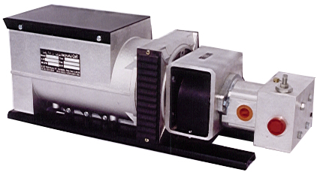

240 V
50 Hz

4800
Watts
1 Phase
\

QUALITY FEATURES
Brushless AC Generator |  | Includes Pressure Compensating Flow Regulator
Maintenance Free Design |  | Lifetime Guaranteed Alignment

SPECIFICATIONS
Flow = | 11.0 GPM |  | Volts = | 240
Pressure = | 2000 PSI |  | Amps = | 20 @ 240 V
Speed = | 3000 RPM |  | Watts = | 4800 Continuous
Weight = | 141 Lbs |  | Power Factor = | 1.0
Dimensions = | 8” W * 10” H * 27” L |  | Temperature Rating = | 105 C
FERNDALE, NY 12734
(845)-292-0800
http://www.getec.com

